# Software Requirements Specification

## Purpose

The purpose of this document is to build a desktop application to help people manage their time effectively. The app will allow the user to register, manage their todos, tasks, and events.

## Document conventions

|  |  |
| --- | --- |
| WPF | Windows Presentation Foundation |
| DB | Database |
| ER | Entity Relationship |
| UML | Unified Modelling Language |

Intended audience and reading suggestions

This document describes an application for planning your day. It will be useful for people who want to manage time and set reminders for events and tasks. Overall, the application will make you disciplined and help you to spend your time more productive.

## Project scope

The application is a desktop WPF application, based on one DB:

* Relational database which stores data of users, todos, and events.

The purpose of the application is to help people with time management. That's why it must be easy to use with nice UX and modern UI.

## Product features

* An unregistered user can sign-up in the application. During this process, the user has to choose a username and password.  
  ○ When the user chooses an existing username he will be notified about it and will be asked to choose another username.  
  ○ The user enters a new username and chooses a password he has successfully registered in the system.
* The registered user can log in. To do this, the user has to enter a username and password.
  + In case of entering a wrong password, the user will be notified about it and will be asked to try to enter the correct username/password.
  + In case of entering the correct username and password, the user is created and logged in.
* The registered user can log-out.
* The registered user can create/edit/delete todos that are stored only for the current day and are deleted after the new day starts.
* The registered user can create/edit/delete tasks with specific deadlines.
* The registered user can create/edit/delete scheduled events.

Nonfunctional Requirements

* The new product shall be easy to use by any members (age 4 to 80) of the public who may only have one hand free.
* The product shall be able to be used by adult members of the public without training.
* The product shall not use picture icons that could be considered offensive in any country where the product is used.
* Supported systems: Windows 7-10.
* .Net Framework 4.8 must be installed on your PC.
* Language: English
* Each window must load within 0.5 seconds.

## 

## 

## 

## 

## 

## 

## 

## 

## 

## 

## User class and characteristics

User classes and characteristics can be demonstrated by the use case UML diagram:

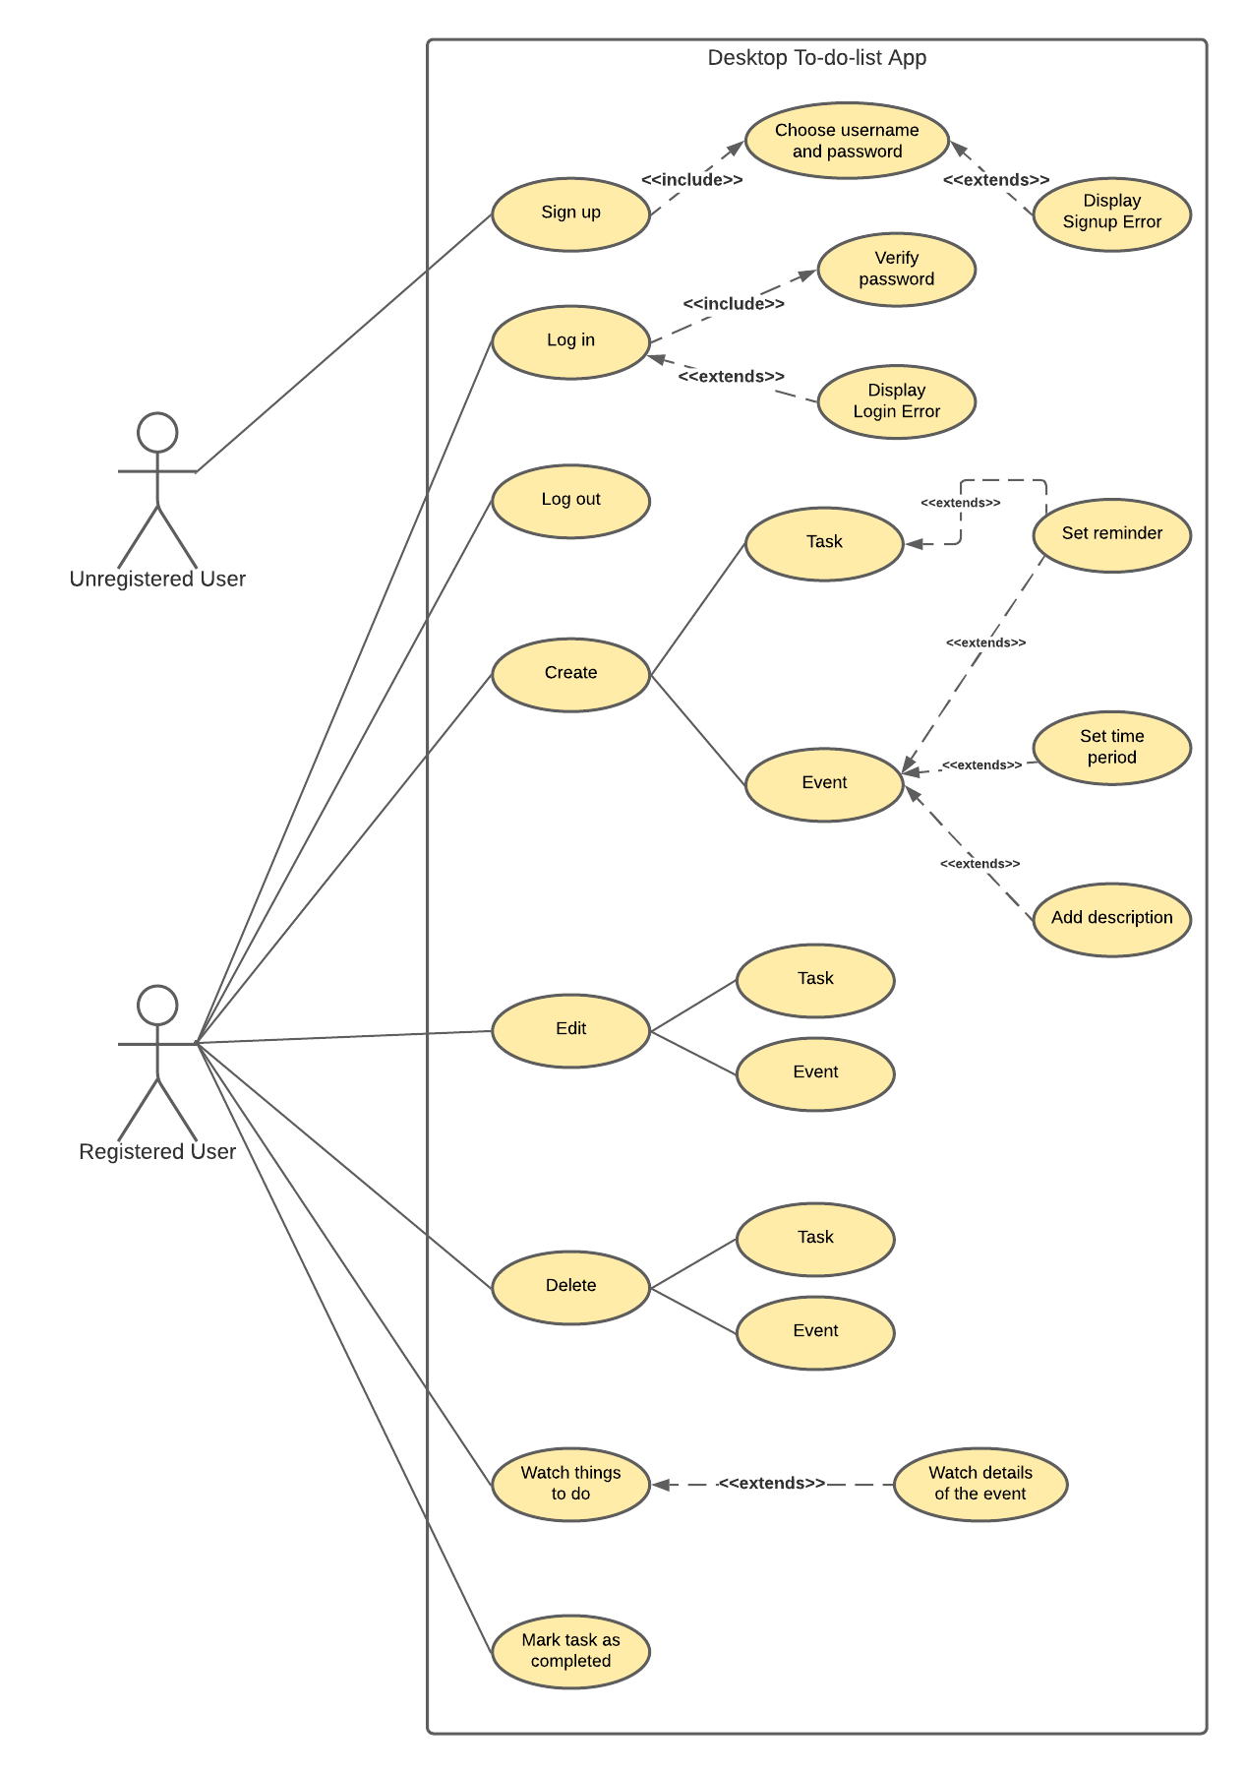

**Use cases description:**

|  |  |  |  |
| --- | --- | --- | --- |
| № | Name | Functionality | Description |
| 1 | Sign up | Creates a new account | The user creates a new personal account and fills it with relevant information. |
| 2 | Log in | Sign in to existing account | The user takes to his personal account via login and password. |
| 3 | Log out | A registered user signs out of their account | The User signs out of their account. After that, the User is not able to see their tasks and events and create them. |
| 4 | Create | A registered user creates one of the suggested actions | The User can create a task or an event. A user creates the name of the task or event. Also, the User can set a reminder for the event and task, add a description, and set a time period for events. |
| 5 | Edit | Registered user edits one of the suggested actions | The User can edit a task or an event. The User can edit name, description, reminder, or time period. |
| 6 | Delete | A registered user deletes one of the suggested actions | The User can delete a task or an event. After that task or event disappears from the timeline. |
| 7 | Watch things to do | Registered user sees created tasks and events. | The User can see the tasks and events he created. Besides, the User can see details of events. |
| 8 | Mark task as completed | Registered user marks a created task as completed. | The User can mark the created task as completed. After this action task is crossed out. |

Operating environment

The operating environment for the ToDoList application is listed below:

* Database: -
* Work with DB: Entity Framework
* Interface: WPF / .NET Framework

User interfaces

Start window:

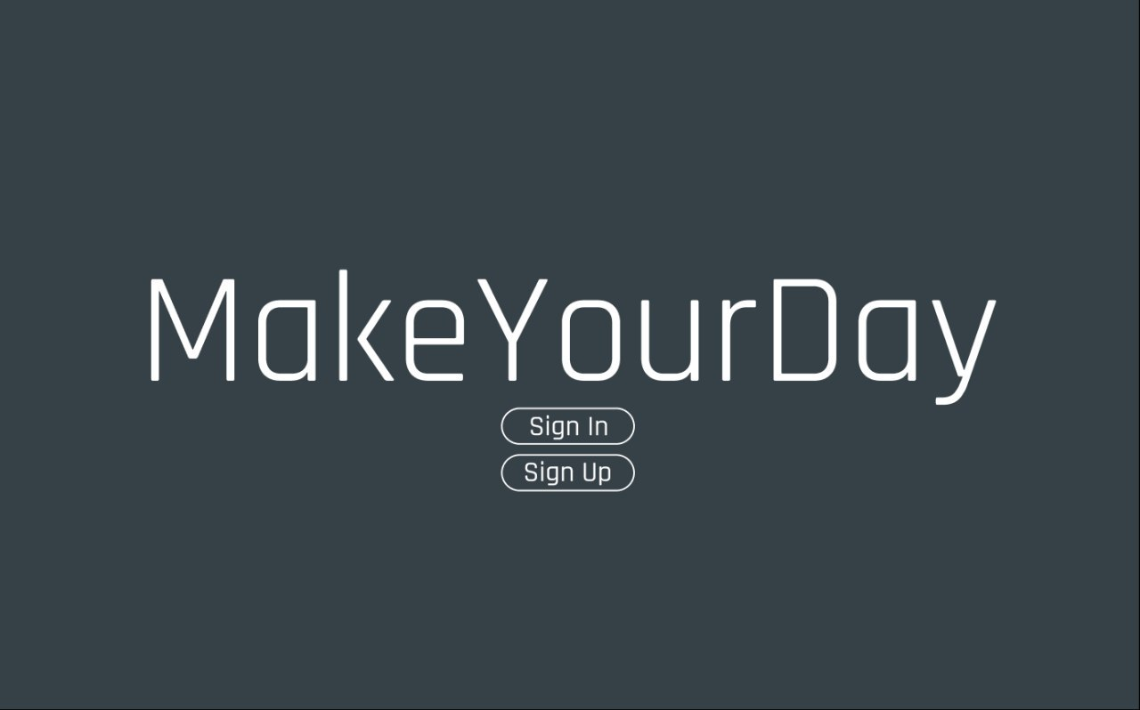

Sign-in and sign-up windows:

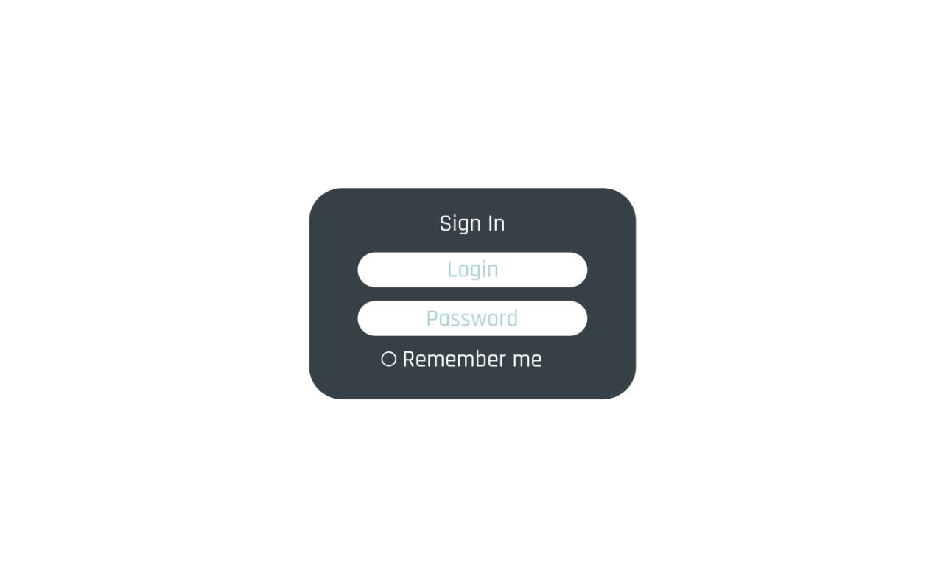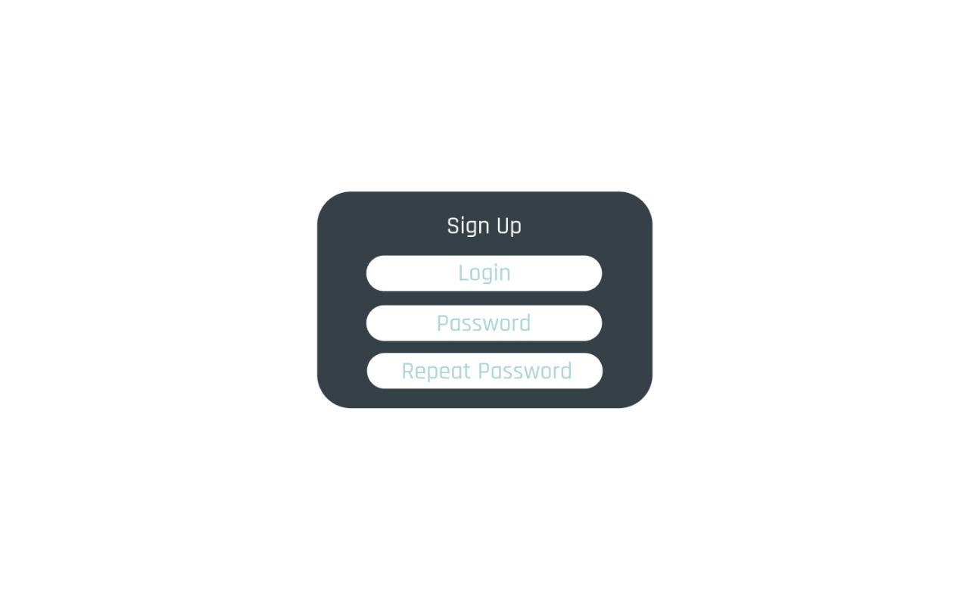

Welcome window:

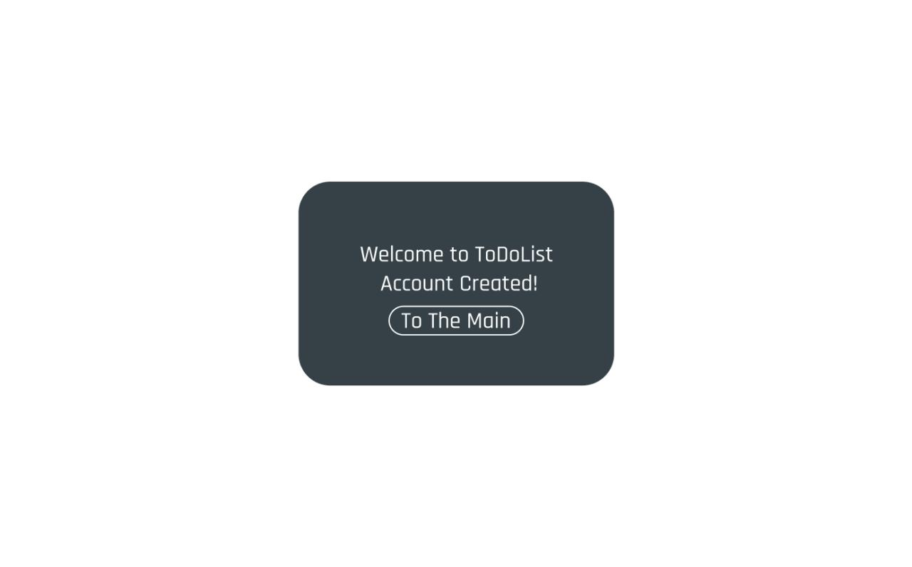

Main window:

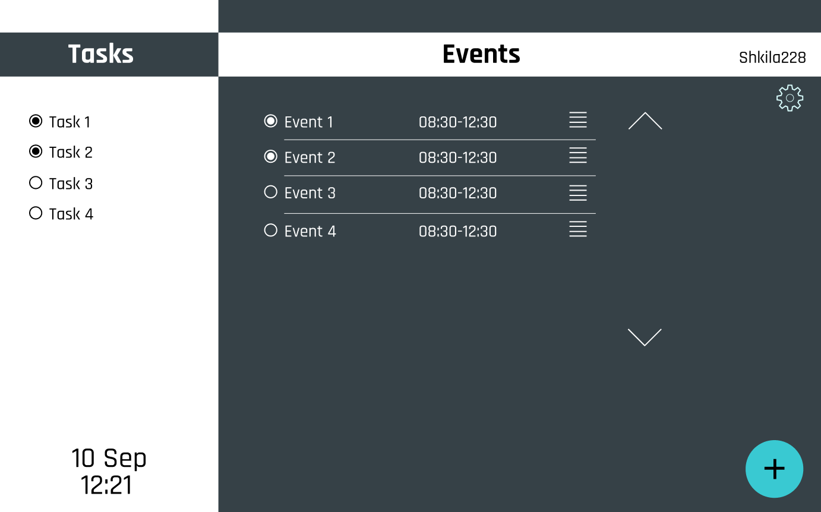

Events details:

